# Question 1

The purpose of the query is to link the Rental, Customer, and Vehicle tables to see what model vehicle each customer has rented so far.

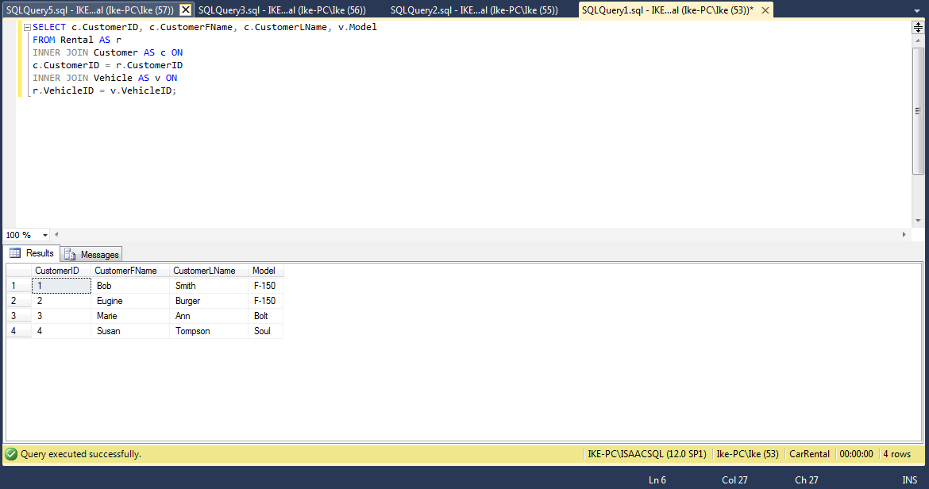

# Question 2

The purpose of the stored procedure is to retrieve the first name, last name, and phone number of a customer when the first name is being searched. This can easily be modified to search for any other customer on a first name basis. It can also be modified to search for a last name by changing the where clause.

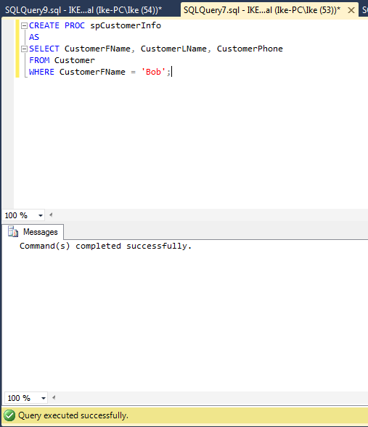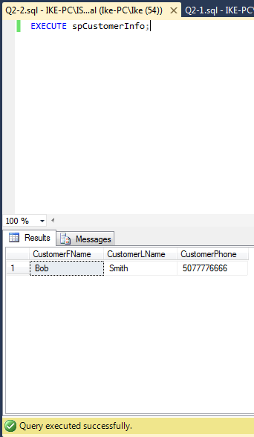

# Question 3

The cursor below shows the make and year of all vehicles registered within the system. More columns can be added to show additional vehicle details, but due to performance constraints within this cursor, it functions much faster to only retrieve two columns instead.

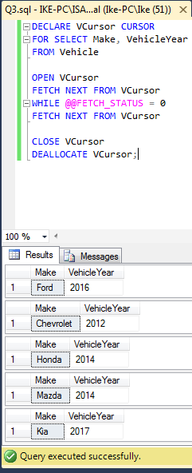

# Question 4

The purpose of the CTE is to show the total number of vehicle types within the database.

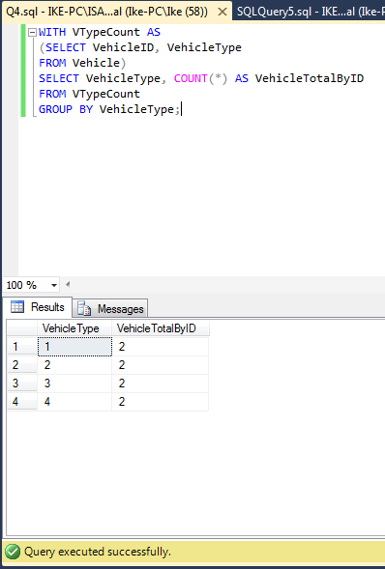

# Question 5

A nonclustered index was created to show the newest vehicles in terms of the year it was manufactured in addition to the make and model.

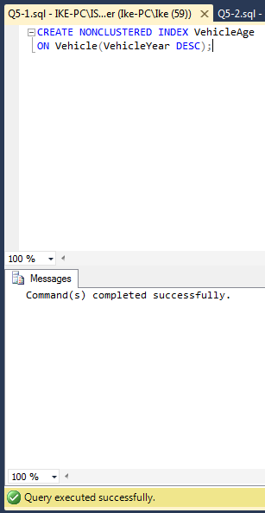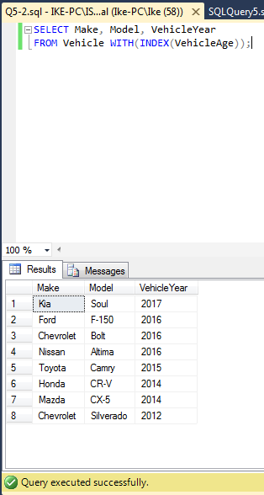

# Question 6

The previously created index was joined with the customer table to see which customers rented which vehicles, while still being sorted by year of manufacture.

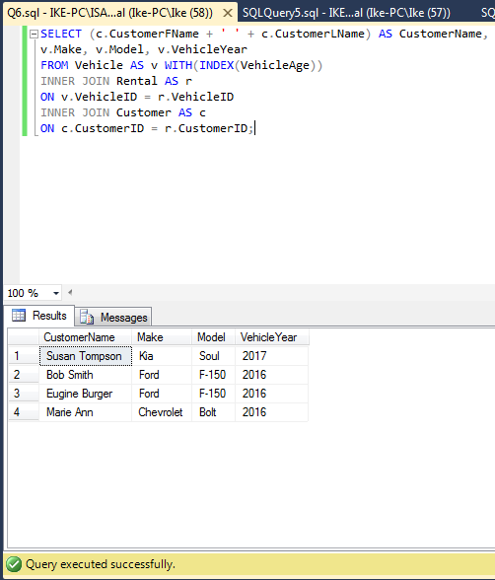

# Question 7

The trigger below will print a simple message to the user after an entry has been inserted, updated, or deleted in the Customer table.

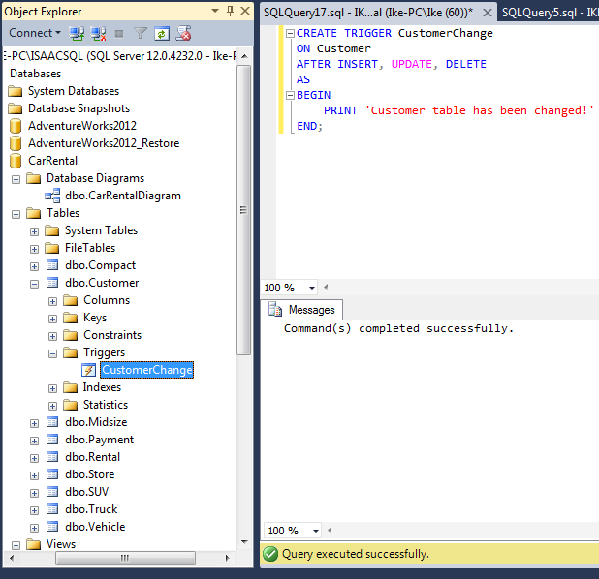

# Question 8

The view created is a simple select statement that shows a portion of the store information for a quick reference. A more complex query could be made into a view with the same syntax as well as using the view.

# C:\Users\Ike\Documents\SQL Server Management Studio\Assignment 4\Q8-1.PNGC:\Users\Ike\Documents\SQL Server Management Studio\Assignment 4\Q8-2.PNG

# Question 9

The pivot table below is a modified version of a previous query that shows the total count of vehicles that fall into one of the four vehicle types. Once again, it shows the correct count of 2 vehicles per vehicle type.

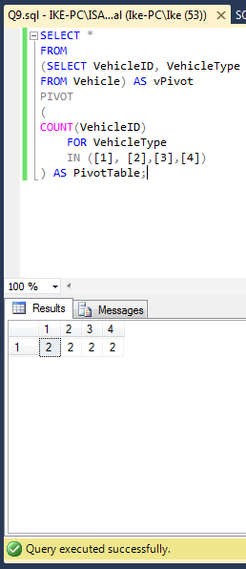

# Question 10

